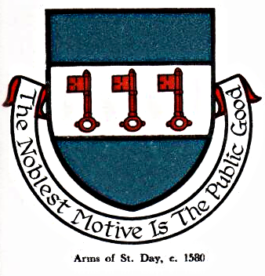 St Day Parish Council

Agenda for the Meeting of the Parish Council to be held on Monday 10th April, 2017, immediately after the conclusion of the Annual Parish Meeting in the Mills Street Community Room.

- Apologies

- Declarations of Personal and Prejudicial Interests relating to items on the agenda and the details thereof

3. Public Participation (to be limited to 15 minutes)

4. Police report

- Cornwall Councillor’s report

- Confirmation of the Minutes of the meetings held on Monday 13th March, 2017

7. Matters arising
a. Town regeneration
- Footpaths
- Public transport & bus shelters
- Play areas & gardens
e. Surgery facilities
f. Empty properties
g. Burial ground and churchyard
h. St Day Old Church
i. Mine workings, Telegraph St
j. Parish website
k. Speedwatch
l. Carols in the Square

8. Correspondence received
a. from Charter for Cornwall - letter of thanks for our support
b. from St Day Youth & Sports Association - request for grant
c. from CC re Off-Street Parking Order, 2017
d. from CC re burial ground, non-domestic rates demand, 2017/8

9. Planning

10. Accounts

11. Traffic and roads

12. Meeting reports

13. Financial report, end of year 2016/7

14. St Day in Bloom, judging

15. Date of the next meeting

Stephen Edwards,
Parish Clerk.

