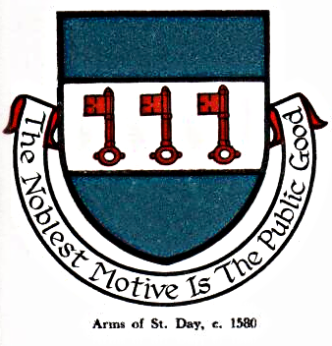 St Day Parish Council

Agenda for the Meeting of the Parish Council to be held on Monday 12 June, 2017, in the Mills Street Community Room.

- Apologies

- Declarations of Personal and Prejudicial Interests relating to items on the agenda and the details thereof

3. Public Participation (to be limited to 15 minutes)

4. Police report

- Cornwall Councillor’s report

- Confirmation of the Minutes of the meetings held on Monday 08th May, 2017

7. Matters arising
a. Town regeneration
- Footpaths
- Public transport & bus shelters
- Play areas & gardens
e. Surgery facilities
f. Empty properties
g. Burial ground and churchyard
h. St Day Old Church
i. Speedwatch
j. Carols in the Square
k. St Day in Bloom judging

8. Correspondence received
a. from St Day & Carharrack 20 is Plenty Group
b. from St Day Parochial Church Council
c. from the Ronnie Richards Memorial Charity re public award ceremony
d. from Cornwall Legal re Summer Training Event
e. from CALC re training events
f. from Cormac re School 'Keep Clear' markings
g. from Life Saver Technology re defibrillator training and upkeep
h. from CC re Cornwall Site Allocations Development Plan Document

9. Planning

10. Accounts

11. Traffic and roads

12. Meeting reports

13. Co-option of a Parish Councillor

14. Review of Standing Orders

15. Date of the next meeting

Stephen Edwards,
Parish Clerk.

