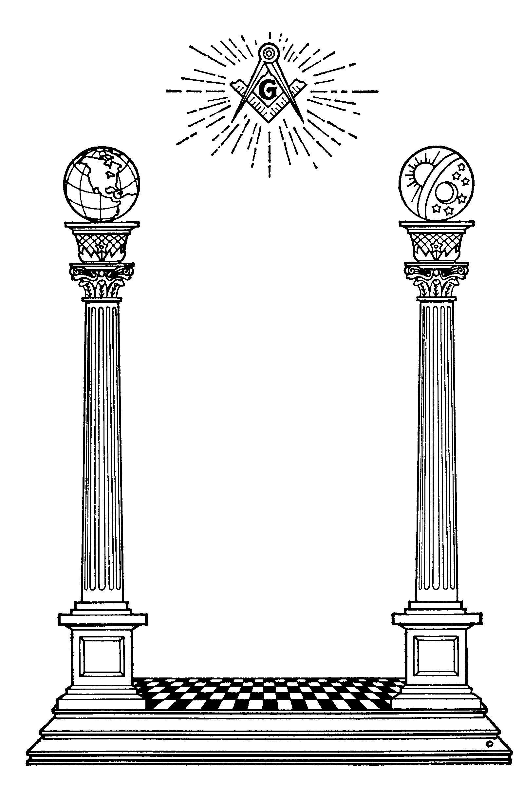

**To commemorate the Tercentenary of Freemasonry (300th Anniversary) from 2pm to 5pm on Saturday the 17th of June the St Day, Masonic Hall will be open to the residents and friends of St Day.**

**There will be a brief talk covering the History of Freemasonry and Freemasonry in St Day after which cream teas will be served (free of charge) to those wishing to join us in our celebration**



**On the evening of the 17th we will also be holding a Musical Event which will start at 7.30 pm a Buffet supper will be provided.**

**Admission £5.00 per person**

**Raffle with lots of prizes.**