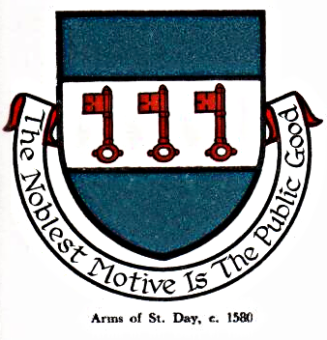 St Day Parish Council

Agenda for the Meeting of the Parish Council to be held on Monday 09th October, 2017, in the Mills Street Community Room.

- Apologies

- Declarations of Personal and Prejudicial Interests relating to items on the agenda and the details thereof

3. Public Participation (to be limited to 15 minutes)

4. Police report

- Cornwall Councillor’s report

- Confirmation of the Minutes of the meeting held on Monday 11th September, 2017

7. Matters arising
a. Town regeneration
- Footpaths
- Public transport & bus shelters
- Play areas & gardens
e. Surgery facilities
f. Empty properties
g. Burial ground and churchyard
h. St Day Old Church
i. Speedwatch
j. Neighbourhood Development Plan
k. Defibrillators
l. St Day & Carharrack Community School, membership of the governing body
m. Small works committee
n. Electoral Review of Cornwall Council

8. Correspondence received
a. from A Bray re bus shelters at Scorrier
b. from S Bessell re donation/public seat
c. from NetWise Training Ltd re website

9. Planning

10. Accounts

11. Traffic and roads

12. Meeting reports

13. Review of burial ground charges

14. Date of the next meeting

Stephen Edwards,
Parish Clerk.

