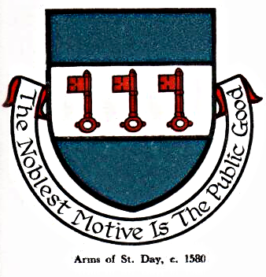 St Day Parish Council

Agenda for the Meeting of the Parish Council to be held on Monday 11th December, 2017, in the Mills Street Community Room.

- Apologies

- Declarations of Personal and Prejudicial Interests relating to items on the agenda and the details thereof

3. Public Participation (to be limited to 15 minutes)

4. Police report

- Cornwall Councillor’s report

- Confirmation of the Minutes of the meeting held on Monday 13th November, 2017

7. Matters arising
a. Town regeneration
- Footpaths
- Public transport & bus shelters
- Play areas & gardens
e. Surgery facilities
f. Empty properties
g. Burial ground and churchyard
h. St Day Old Church
i. Speedwatch
j. Neighbourhood Development Plan
k. Defibrillators
l. Minor works committee
m. Donations
n. Fairfields, Telegraph Hill

8. Correspondence received
a. from iSight Cornwall re grant
b. from Cornwall Ai Ambulance re grant
c. from CC re Winter Wellbeing guides
d. from NHS Kernow re :Public Exhibition & Networking Event
e from the Smaller Authorities Audit Appointments Ltd re Audit appointment, 2017/18 - 2021/22
f from CC Communities & Devolution re household waste & recycling collection arrangements
g from CC - Cornwall Statement of Community Involvement for Planning
h from St Day Old Church CIC re handover of ownership

9. Planning

10. Accounts

11. Traffic and roads

12. Meeting reports

13. Report from Finance meeting held on 05 December

14. Budget and precept, 2018/19

15. Date of the next meeting

Stephen Edwards,
Parish Clerk.

