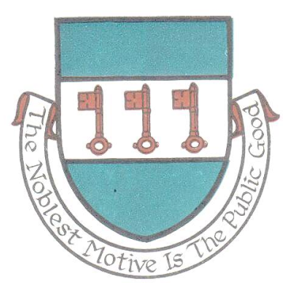

St Day Parish Council

Agenda for the Annual Parish Meeting of St Day to be held on Monday 10th April, 2017, at 7.00.pm in the Mills Street Community Room, St Day.

- Apologies and Chairman’s remarks.

- Confirmation of the Minutes of the Annual Parish Meeting held on Monday 11th April, 2016.

- Report by the Chairman on the activities of the Parish Council during the year 2016/17.

- Report by Cornwall Councillor on activities during the year 2016/17.

- Report by the Clerk on the details of the audit for the financial year 2015/16.

- Statement of Accounts for the financial year 2016/17.

7. Public discussion.

Stephen Edwards
Stephen Edwards,
Clerk.

