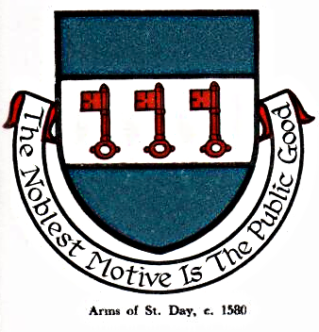 St Day Parish Council

Agenda for the Meeting of the Parish Council to be held on Monday 13th March, 2017, at 7pm in the Mills Street Community Room.

- Apologies

- Declarations of Personal and Prejudicial Interests relating to items on the agenda and the details thereof

3. Public Participation (to be limited to 15 minutes)

4. Police report

- Cornwall Councillor’s report

- Confirmation of the Minutes of the meetings held on Monday 13th February, 2017

7. Matters arising
a. Town regeneration
- Footpaths
- Public transport & bus shelters
- Play areas & gardens
e. Surgery facilities
f. Empty properties
g. Burial ground and churchyard
h. St Day Old Church
i. Mine workings, Telegraph St
j. Parish website
k. Speedwatch
l. Welcome packs

8. Correspondence received
a. from Charter for Cornwall re support for its four pledges
b. from the Tregullow Lodge re defibrillator training
c. from Coastline Housing re Affordable Housing development on Telegraph Hill
d. from St Day WI re Carols in the Square
e. from the North Coast Cluster group re payment of business rates on public conveniences
f. from Rachel Graham re 'I' bar outside Holy Trinity Church and adjacent properties
g. from the Police & Crime Commissioner re CCTV systems

9. Planning

10. Accounts

11. Traffic and roads

12. Meeting reports

13. To set a date for the Annual Parish Meeting

14. To set a date for the end of year Finance Committee Meeting

15. Date of the next meeting

Stephen Edwards,
Parish Clerk.

