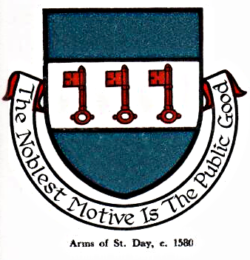 St Day Parish Council

Agenda for a Planning Meeting to be held on Wednesday 09th August, 2017, at 7.15pm in the Community Room, Mills Street.

- Apologies

- Declarations of Personal and Prejudicial Interests relating to items on the agenda and the details thereof

3. Public Participation (to be limited to 15 minutes)

4. Planning
PA17/07028 Mercer & Rainey Chyloe, Pink Moors demolition of bedroom & part front conservatory & construction of two-storey extension

Stephen Edwards

Stephen Edwards,
Parish Clerk.

