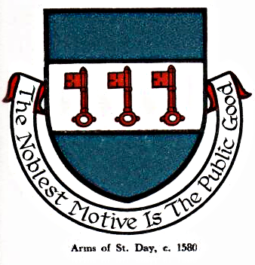 St Day Parish Council

Agenda for the Meeting of the Parish Council to be held on Monday 13th November, 2017, in the Mills Street Community Room.

- Apologies

- Declarations of Personal and Prejudicial Interests relating to items on the agenda and the details thereof

3. Public Participation (to be limited to 15 minutes)

4. Police report

- Cornwall Councillor’s report

- Confirmation of the Minutes of the meeting held on Monday 09th October, 2017

7. Matters arising
a. Town regeneration
- Footpaths
- Public transport & bus shelters
- Play areas & gardens
e. Surgery facilities
f. Empty properties
g. Burial ground and churchyard
h. St Day Old Church
i. Speedwatch
j. Neighbourhood Development Plan
k. Defibrillators
l. Minor works committee
m. Electoral Review of Cornwall Council
n. Donations
o. Fairfields, Telegraph Hill

8. Correspondence received
a. from S Roberts re recycling collections, Mineral Way
b. from Cornwall Council re Local Town & Parish Council Planning conferences
c. from Cornwall Council re submission of the Cornwall Minerals Safeguarding Development Plan
d. from Cornwall Council re closure of A3047 between Scorrier roundabout and White Cross
e. from Cornwall Council - Neighbourhood Planning e-bulletin
f. from Tim Price, Scorrier Crossroads re proposed new road layout at Scorrier
g. from Cornwall Council Planning Enforcement - quarterly report

9. Planning

10. Accounts

11. Traffic and roads

12. Meeting reports

13. Consideration of grant awards

14. To set a date for the December Finance meeting.

15. Carol singing, Market Square.

16. St Day Notice Board, Facebook page

17. Date of the next meeting

Stephen Edwards,
Parish Clerk.

