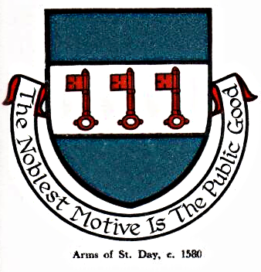 St Day Parish Council

Agenda for the Meeting to be held on Monday 18th June, 2018, at 01.00pm in the Community Room, Mills Street.

- Apologies

- Declarations of Personal and Prejudicial Interests relating to items on the agenda and the details thereof

3. Public Participation (to be limited to 15 minutes)

4. Appointment of Parish Clerk

Stephen Edwards

Stephen Edwards,
Parish Clerk.

