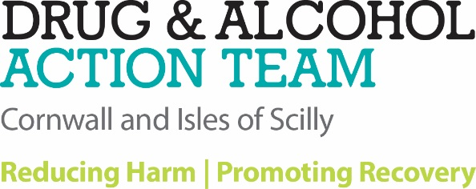

# CASCADE DRUG ALERT 7th July 2018

**Suspected drug related death and hospitalisations- Camborne**

**On the late evening of Friday 6th July a 14 year old girl consumed suspected controlled drugs in the form of tablets in the Camborne area and subsequently died in hospital on 7th July. Two 13 year old girls and a 15 year old boy were also hospitalised having consumed the same tablets.**

**The tablets are described as triangular shaped, pale blue in colour and have been referred to as ‘DUPLO’ as in the larger type Lego building clocks for kids. The below photo is similar but imagine them pale blue in colour.**

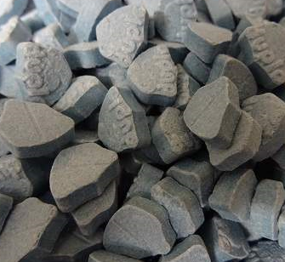

Urgent forensic testing is in progress as is viewing better quality samples to photograph and circulate.

The symptoms displayed by these young people included;

* **Agitation**
* **Hyperpyrexia (core body temperatures above 41.5 degrees centigrade)**
* **Fitting and seizures.**

The exact substance(s) that these tablets contain is not known at this time but the public are warned not to take them.

**These tablets may still be in possession of young people who are at risk of serious illness or death if they consume them.**

In order to keep the public safe it is requested that the described tablets are handed into Police or other safe custody. Please ring **101** and quote **Police log 1187/ 060718**. Alternatively, **Camborne CID** can be contacted on Tel: **01209 611206** where calls will be treated in confidence.

If you witness anyone in distress and suspect the use of these tablets;

**Call 999 for an ambulance**

**Give immediate first aid basic life support (recovery position and monitor the airway, breathing & pulse)**.

Further help and support can be found from the specialist drug and alcohol service-

[](https://www.addaction.org.uk/) **Tel: 0333 200 0325**