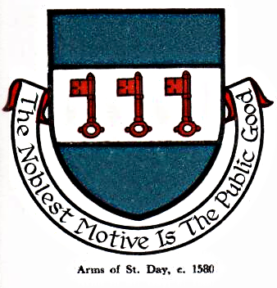 St Day Parish Council

Agenda for the Meeting of the Parish Council to be held on Monday 08th October, 2018, in the Mills Street Community Room

- Apologies

- Declarations of Personal and Prejudicial Interests relating to items on the agenda and the details thereof

3. Public Participation (to be limited to 15 minutes)

4. Police report

- Cornwall Councillor’s report

- Confirmation of the Minutes of the meeting held on Monday 10th September, 2018

7. Matters arising
a. Town regeneration
- Footpaths
- Public transport & bus shelters
- Play areas & gardens
e. Surgery facilities
f. Empty properties
g. Burial ground and churchyard
h. Speedwatch
i. Neighbourhood Development Plan
j. Minor works
k. Current year projects, 2018/19
l. November litter pick.

8. Correspondence received
a. Re. Skate Park
b. Re. United Downs Deep Geothermal Power Project
c. Re. Problems relating to oversized trees
d. Re. Sans Day Carol
e. Re. Problems relating to enforcement to be discussed under the appropriate heading
f. Re. Community mini bus
g. Re. Cornwall Council granting rural exception sites
h. Re. Subsidence
i. Re. Drain odour

9. Planning

10. Accounts

11. McAfee Virus protection DD to be set up

12. Traffic and roads

13. Meeting reports

14. Date of the next meeting - Monday 12th November

Sarah Moore,
Parish Clerk.

