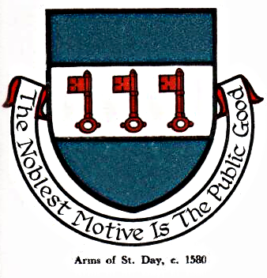 St Day Parish Council

Agenda for the Meeting of the Parish Council to be held on Monday 3rd December 2018,

Main Hall, Enterprise Centre, Vogue. 7pm
- Apologies

- Declarations of personal and prejudicial interests relating to items on the agenda and the details thereof

3. Public Participation (to be limited to 15 minutes)

4. Police Report

- Cornwall Councillor’s Report

- Confirmation of the minutes of the meeting held on Monday 12th November, 2018

7. Matters arising
a. Town Regeneration
b. Footpaths
c. Public Transport & Bus Shelters
d. Play Areas & Gardens
e. Surgery Facilities
f. Empty Properties
g. Burial Ground and Churchyard
h. Speed Watch
i. Neighbourhood Development Plan
j. Christmas lights
k. Minor Works
l. Current Year Projects, 2018/19

8. Correspondence/Communications Received

9. Planning

10. Accounts/Banking

11. 2019/20 Budget

12. Traffic and Roads

13. Upcoming Meetings

14. Meeting Reports

15. Casual Vacancy Applications (in camera)

15. Date of the next meeting - Monday 14th January

Sarah Moore, Parish Clerk.

