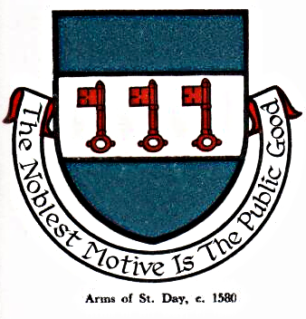 St Day Parish Council

Agenda for the Meeting of the Parish Council to be held on Monday 12th November 2018, Mills St. Community Room

- Apologies

- Declarations of personal and prejudicial interests relating to items on the agenda and the details thereof

3. Public Participation (to be limited to 15 minutes)

4. Police Report

- Cornwall Councillor’s Report

- Confirmation of the minutes of the meeting held on Monday 08th October, 2018

7. Matters arising
a. Casual vacancies for 2 New Councillors
b. Town Regeneration
c. Footpaths
d. Public Transport & Bus Shelters
e. Play Areas & Gardens
f. Surgery Facilities
g. Empty Properties
h. Burial Ground and Churchyard
i. Speed Watch
j. Neighbourhood Development Plan
k. Geothermal Panel for Grants
l. CLLD Grants Panel
m. Minor Works
n. Current Year Projects, 2018/19
o. Litter Pick

8. Correspondence/Communications Received

9. Planning

10. Accounts/Banking

11. Upgrade of Laptop software

12. Traffic and Roads

13. Upcoming Meetings

14. Meeting Reports

15. Date of the next meeting - Monday 03rd December

Sarah Moore, Parish Clerk.

