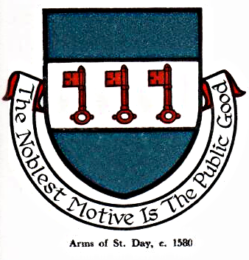 St Day Parish Council

Agenda for a Meeting to be held on Monday 4th March, 2019, at 7pm at Enterprise Centre, Vogue.

- Apologies

- Declarations of Personal and Prejudicial Interests relating to items on the agenda and the
- details thereof

3. Public Participation (to be limited to 15 minutes)

4. Burial plot request

Meeting called by Sarah Moore
Parish Clerk.

