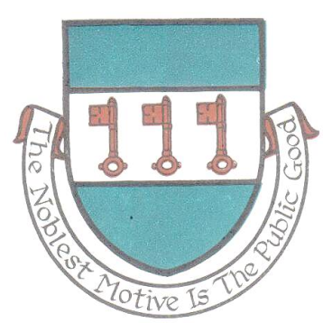

St Day Parish Council

Agenda for the Annual Parish Meeting of St Day to be held on Monday 08th April, 2019, at 6.30pm in the Enterprise Centre, Vogue, St Day.

- Apologies and Chairman’s remarks.

- Confirmation of the Minutes of the Annual Parish Meeting held on Monday 9th April, 2018.

- Report by the Chairman on the activities of the Parish Council during the year 2018/19.

- Report by Cornwall Councillor on activities during the year 2018/19.

- Report by the Clerk on the details of the audit for the financial year 2017/18.

- Statement of Accounts for the financial year 2018/19.

7. Public discussion.

Sarah Moore
Clerk.

