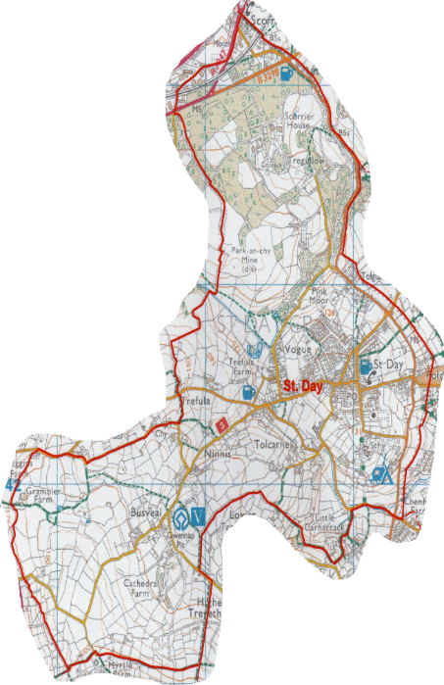
What is a Neighbourhood Development Plan?
Neighbourhood Development Plans (NDP) can set out local level planning policies for that area, shaping future development.

Under the Localism Act 2011, Parish and Town Councils can write a NDP for their area with the help of their community.

Subject to conforming to National policies, the Cornwall Local Plan strategic policies, an independent examination and gaining support through a referendum of residents, this plan will be adopted as a formal planning policy by Cornwall Council.

This means that planning decisions in our Parish will have to be made in accordance with the NDP.

St Day, Scorrier and Busveal Neighbourhood
Development Plan Survey 2022

This is your opportunity to influence the future development of the Parish and your opinion matters. Please complete this survey by 1stApril 2022.
St Day Parish Council is working with the community to produce a Neighbourhood Development Plan for the Parish, which includes Scorrier and Busveal, to ensure that the community can shape the future development of our area.
If you have difficulty in completing this survey for any reason, or if the survey is required in another format, please contact the Parish Clerk on 078260 856262 or email stdaypc@gmail.com
We want everyone to have an active say in the future of the Parish and would like to know what you think. Please take the time to fill in this quick survey and let us know your views.

Additional copies of the survey can be obtained from St Day Post Office, or by email – via the Parish Clerk (stdaypc@gmail.com)

Questionnaire Number 1
- What are three positive things you like about the Parish?
1
2
3
- What do you think are three things which could be improved about the Parish?
1
2
3
- Do you think producing an NDP for the Parish is a good idea?
(please circle )
Yes | NO
- Please explain why.
- Please indicate below FIVE topics you feel are the most important to be included (please circle Five topics for your response)
Wildlife | Recreation/Leisure Facilities | Historic Environment/Heritage
Landscape | Community Facilities | Open Spaces/Footpaths etc.
Accessibility | Renewable Energy | Housing, design, number, type
Transport/ Traffic | Economy / Jobs | Education / Skills
Climate Change | Location of development | Second Homes
- Please state below any other topic you feel should be covered which is not listed above:
- Personal Information – OPTIONAL
Post code |  | Do you live in the Parish? Y or N |  | Do you commute of the parish for work or school? Y or N
Age Range | Under 14 | 14- 21 | 22-40 | 41- 59 | 60 +

Thank you for taking the time to fill in the survey
Your Community Needs You!

Would you be willing to complete a longer survey? (please circle)
Yes | NO

Would you like to be involved in the production of the NDP? For example as a member of a Steering Group, provide specialist input, or help with consultation and community engagement? (please circle)
Yes | NO

If you have answered 'Yes' to any of the above 2 questions please complete below:
Name:
Address:

Telephone Number:
Email:

Please note all personal details will be retained within the Data Protection Act and NO information provided in this survey will be linked to an individual.

How to submit your response:

- Tear out the survey from your newsletter and drop into the pages into: Scorrier Christian Fellowship Church
St Day Post Office
The Star Inn at Vogue

- Complete online at https://forms.office.com/r/GPkC8DEnKw

Please complete and return by 1st April 2022

