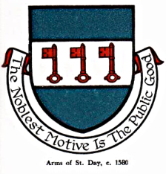

INTERIM AGENDA FOR THE MEETING OF ST DAY PARISH COUNCIL

I hereby give you notice that St Day Parish Council meeting will be held on Monday 4th April, 2022 commencing promptly at 7.00pm. Physical Public Attendance within the current guidelines is allowed.

- Chairman’s welcome and any apologies

- Election of New Chairman

3. Public Participation (to be limited to 15 minutes)

4. Declarations of Personal and Prejudicial Interests relating to items on the agenda

5. Cornwall Councillor’s report

6. Confirmation of minutes from meeting held on 14.03.22

7. Planning - To receive and comment on recent planning applications to date:
PA22/01947 - Little Menheer Farm, Higher Ninnis

8. Matters arising
a. Speed Watch
b. Current year projects/events
c. Surgery Facilities
d. Climate Update
e. Burial Ground and churchyard
f. Bins and dog fouling
g. Footpaths, play areas and gardens
h. Neighbourhood development plan
i. Minor Works
j. Neighbourhood Watch Scheme
k. Any matters arising, between printing of agenda and meeting date

9. Correspondence / communications received

10. Accounts / banking

11. Traffic and roads

12. Report on any external meetings attended

13. Upcoming meetings

14. Planning enforcement (in camera)

15. Date of the next meeting and Annual Parish Meeting

