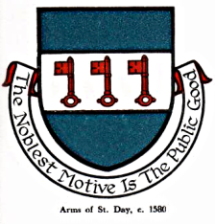

INTERIM AGENDA FOR THE MEETING OF ST DAY PARISH COUNCIL

I hereby give you notice that St Day Parish Council meeting will be held on Monday 11th July, 2022 commencing promptly at 7.00pm. Public Attendance is invited.

- Chairman’s welcome and any apologies

- Public Participation (to be limited to 15 minutes)

3. Declarations of Personal and Prejudicial Interests relating to items on the agenda

4. Confirmation of minutes from meeting held on 13.06.22

- Planning - To receive and comment on recent planning applications to date:
PA22/05404 - Three Firs Farm, Busveal, St Day
PA22/04745- 7, Vogue Hill, St Day

- Cornwall Councillor’s report

- Matters arising
- Current year projects/events
- Town regeneration
- Footpaths
- Play areas and gardens
- Burial Ground and churchyard
- Neighbourhood development plan
- Climate Update
- Bins and dog fouling
- Minor Works
- Speed Watch
- Surgery Facilities
- Car Park potential in St Day
- Mayor of Cornwall
- Newsletter
o. Any matters arising, between printing of agenda and meeting date

8. Correspondence / communications received

9. Accounts / banking

10. Traffic and roads

11. Report on any external meetings attended

12. Upcoming meetings

13. Planning enforcement (in camera)

14. Date of the next meeting (September)

