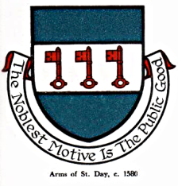

INTERIM AGENDA FOR THE MEETING OF ST DAY PARISH COUNCIL

I hereby give you notice that St Day Parish Council meeting will be held on Monday 14th November, 2022 commencing promptly at 7.00pm. Public Attendance is invited.

- Chairman’s welcome and any apologies

- Public Participation (to be limited to 15 minutes)

3. Declarations of Personal and Prejudicial Interests relating to items on the agenda

4. Confirmation of minutes from the last meeting, held on 10.10.22

- Planning - To receive and comment on recent planning applications to date:
PA22/06020 - Land West of Hope Cottage, Tolcarne Rd
PA22/09202 - Donkey Track Cottage, Little Carharrack
PA22/08975 - Chyloe, Pink Moors
PA22/07824 - Fir Trees Cottage, Scorrier

- Cornwall Councillor’s report

- Matters arising
- Current year projects/events
- Town regeneration
- Footpaths
- Play areas and gardens
- Burial Ground and churchyard
- Neighbourhood development plan
- Climate Update
- Bins and dog fouling
- Minor Works
- Speed Watch
- Surgery Facilities
- Parking in St Day
- Any matters arising, between printing of agenda and meeting date

8. Correspondence / communications received

9. Accounts / banking

10. Traffic and roads

11. Report on any external meetings attended

12. Upcoming meetings

13. Planning enforcement (in camera)

14. Date of the next meeting

