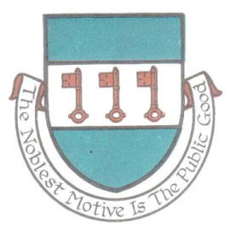

St Day Parish Council

Draft Minutes for the Annual Parish Meeting of St Day held on Monday 17th April, 2023 at 6.15pm in the Enterprise Centre, Vogue, St Day.

Present: Cllr James Beer, Cllr Zoe Abbotts, Cllr Darrell Christie, Cllr Demelza Stevenson, Cornwall Councillor Connor Donnithorne and Parish Clerk, Sarah Moore.

There were no members of the public present.

- Apologies and Chairman’s remarks. Chairman’s welcome and apologies were expressed from Cllr Clive Jones and Cllr Matthew McEvoy

- Confirmation of the Minutes of the Annual Parish Meeting held on Monday 9th May, 2022. Agreed as a true representation of the last meeting. Signed and dated by Cllr James Beer.

- Report by the Chairman on the activities of the Parish Council during the year 2022/23. This was circulated prior to the meeting. It was noted what a wonderful and interactive community, St Day is.

- Report by Cornwall Councillor on activities during the year 2022/23. This was circulated prior to the meeting.

- Report by the Clerk on the details of the audit for the financial year 2021/22. It was noted that there was an mis-recorded date on the submitted AGAR, and the action was to ensure accuracy in future submissions.

- Statement of Accounts for the financial year 2022/23.
The final accounts were presented by the Clerk and AGREED as correct
Start balance in all accounts | 68,410.72
Plus receipts | 49,732.96
Minus payments | 39,750.34
£78,693.34 minus £300.00 un-cashed cheque (Silver Band) | £78,393.34

- Public discussion. There was no public participation.

Meeting closed at 6:45pm

Meeting minuted by Sarah Moore, Parish Clerk.

