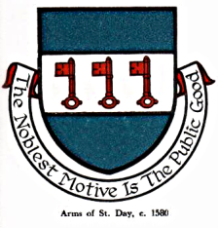

INTERIM AGENDA FOR THE MEETING OF ST DAY PARISH COUNCIL

I hereby give you notice that St Day Parish Council meeting will be held on Monday 13th November, 2023 commencing promptly at 7.00pm, at the Enterprise Centre, Vogue, St Day. Public Attendance is invited.

- Chairman’s welcome and any apologies

- Public Participation (to be limited to 15 minutes)

3. Declarations of Personal and Prejudicial Interests relating to items on the agenda

4. Confirmation of minutes from the last meeting, held on 09.10.23

- Cornwall Councillor’s report

- Planning - To receive and comment on recent planning applications:

Application PA23/08112 - Retrospective siting of a Laundry Building at Grambler Farm Sandy Lane Redruth

- Matters arising
- Current year projects/events
- Town regeneration
- Footpaths
- Play areas and gardens
- Burial Ground and churchyard
- Neighbourhood development plan
- Climate Update
- Bins and dog fouling
- Minor Works
- Speed Watch
- Councillor applications (in camera)
- First Aid and Safeguarding Training
- Any matters arising, between printing of agenda and meeting date

8. Correspondence / communications received

9. Accounts / Banking / Draft Budget for 2024-25

10. Traffic and roads

11. Report on any external meetings attended

12. Upcoming meetings

13. Planning enforcement (in camera)

14. Date of the next meeting

