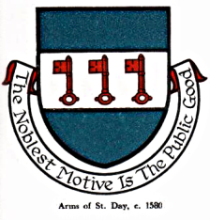

INTERIM AGENDA FOR THE MEETING OF ST DAY PARISH COUNCIL

I hereby give you notice that St Day Parish Council meeting will be held on Monday 12th February, 2024 commencing promptly at 7pm at the Enterprise Centre, Vogue, St Day. Public Attendance is invited.

- Chairman’s welcome and any apologies

- Public Participation (to be limited to 15 minutes)

3. Declarations of Personal and Prejudicial Interests relating to items on the agenda

4. Confirmation of minutes from the last meeting, held on 08.01.24

- Cornwall Councillor’s report

- Planning - To receive and comment on recent planning applications:

Application PA24/00030 - The Barn, Burnwithian Terrace, St Day
Application PA24/00089 - Land South East Of Amberley, Tolcarne, St Day
Application PA23/10390 - Community Sports Hall, Vogue Hill, St Day
Application PA23/10125 - Parc An Chy Recycling Site, Treskerby, Redruth

- Matters arising
- Current year projects/events
- Town regeneration
- Footpaths
- Play areas and gardens
- Burial Ground and churchyard
- Neighbourhood development plan
- Climate Update
- Bins and dog fouling
- Minor Works
- Speed Watch
- Councillor Vacancy
- Training
- Any matters arising, between printing of agenda and meeting date

8. Correspondence / communications received

9. Accounts / Banking

10. Traffic and roads

11. Report on any external meetings attended

12. Upcoming meetings

13. Planning enforcement (in camera)

14. Date of the next meeting

